**Aim:** **Draw the heat map plot using plotly, matplotlib and seaborn libraries in python on random dataset.**

**IDE:** Excel, Tableau, Spyder IDE

**Theory:**

**Heat Map plot**

A Heat Map in Excel is a visual representation that quickly shows you a comparative view of a dataset. For example, in the dataset below, I can easily spot which are the months when the sales were low (highlighted in red) as compared with other months.

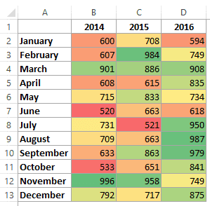

In the above dataset, the colours are assigned based on the value in the cell. The colour scale is Green to Yellow to Red with high values getting the green colour and low values getting the red colour.

**Creating a Heat Map in Excel**

While you can create a heat map in Excel by manually color coding the cells. However, you will have to redo it when the values changes. Instead of the manual work, you can use conditional formatting to highlight cells based on the value. This way, in case you change the values in the cells, the color/format of the cell would automatically update the heat map based on the pre-specified rules in conditional formatting.

In this experiment, you’ll learn how to:

Quickly create a heat map in Excel using conditional formatting.

Create a dynamic heat map in Excel.

Creating a Heat Map in Excel Using Conditional Formatting

If you have a dataset in Excel, you can manually highlight data points and create a heat map.

However, that would be a static heat map as the colour would not change when you alter the value in a cell.

Hence, conditional formatting is the right way to go as it makes the color in a cell change when you change the value in it.

Suppose you have a dataset as shown below:

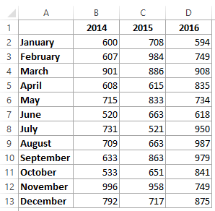

Here are the steps to create a heat map using this data:

Select the dataset. In this example, it would be B2:D13.

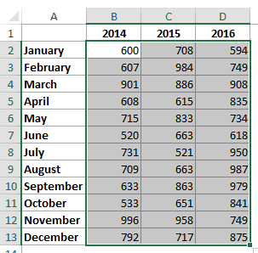

Go to Home –> Conditional Formatting –> Color Scales. It shows various color combinations that can be used to highlight the data. The most common color scale is the first one where cells with high values are highlighted in green and low in red. Note that as you hover the mouse over these color scales, you can see the live preview in the data set.

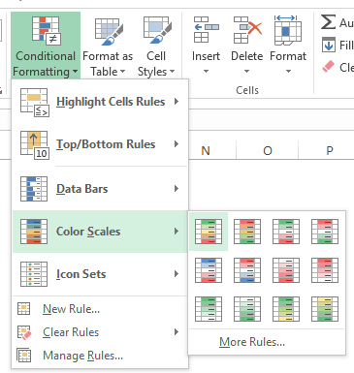

This will give you a heat map as shown below:

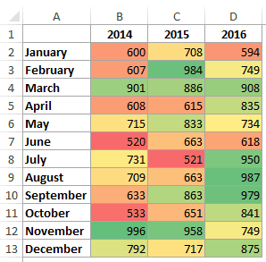

By default, Excel assigns red color to the lowest value and the green color to the highest value, and all the remaining values get a color based on the value. So there is a gradient with different shades of the three colors based on the value.

Now, what if don’t want a gradient and only want to show red, yellow, and green. For example, you want to highlight all the values less than say 700 in red, irrespective of the value. So 500 and 650 both gets the same red color since it’s less than 700.

To do this:

Go to Home –> Conditional Formatting –> Color Scales –> More Options.

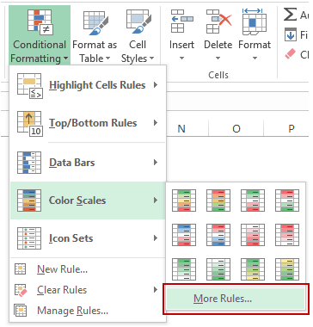

In the New Formatting Rule dialog box, select ‘3-Color scale’ from the Format Style drop down.

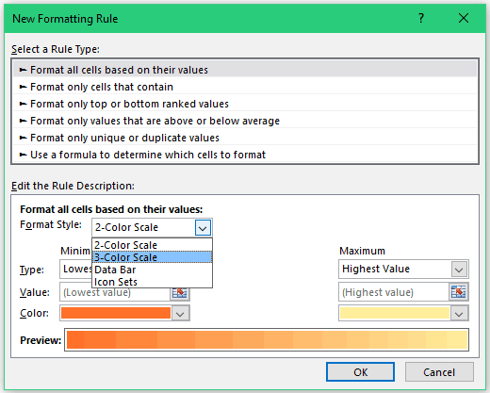

Now you can specify the minimum, midpoint, and the maximum value and assign the color to it. Since we want to highlight all the cells with a value below 700 in red, change the type to Number and value to 700.

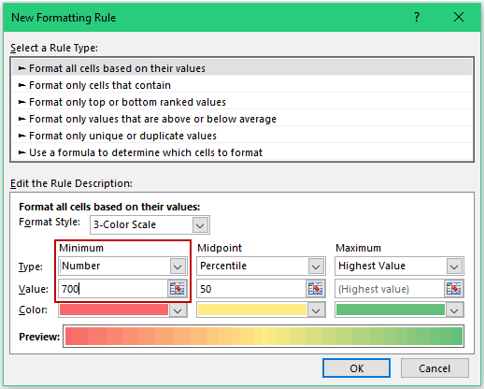

Click OK.

Now you will get the result as shown below. Note that all the values below 700 get the same shade of red color.

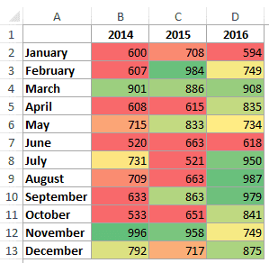

Creating a Dynamic Heat Map in Excel

Since conditional formatting is dependent on the value in a cell, as soon as you change the value, conditional formatting recalculates and changes. This makes it possible to make a dynamic heat map. Let’s look at two examples of creating heat maps using interactive controls in Excel.

Example 1: Heat Map using Scroll Bar

Here is an example where the heat map changes as soon as you use the scroll bar to change the year.



This type of dynamic heat maps can be used in dashboards where you have space constraints but still want the user to access the entire data set.

How to create this dynamic heat map?

Here is the complete data set that is used to create this dynamic heat map.

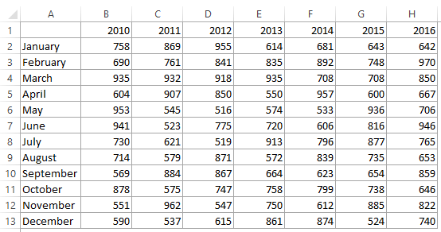

Here are the steps:

* In a new sheet (or in the same sheet), enter the [month names](https://trumpexcel.com/get-month-name-from-date-excel/) (simply copy paste it from the original data).
* Go to Developer –> Controls –> Insert –> Scroll Bar. Now click anywhere in the worksheet, and it will insert a scroll bar. (click here if you can’t find the [developer tab](https://trumpexcel.com/excel-developer-tab/)).

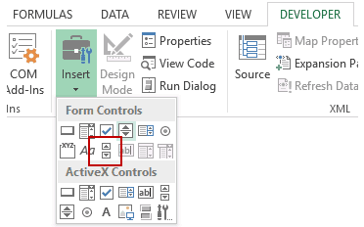

Right-click on the scroll bar and click on Format Control.

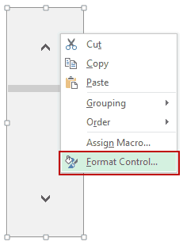

In the Format Control dialog box, make the following changes:

* Minimum Value: 1
* Maximum Value 5
* Cell Link: Sheet1!$J$1 (You can click on the icon in the right and then manually select the cell you want to link to the scroll bar).

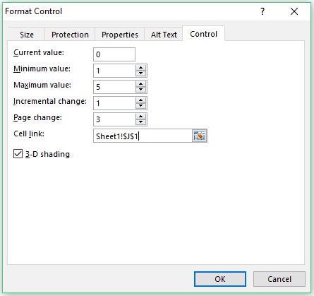

* Click OK.
* In cell B1, enter the formula: =[INDEX](https://trumpexcel.com/excel-index-function/)(Sheet1!$B$1:$H$13,[ROW](https://trumpexcel.com/excel-row-function/)(),Sheet1!$J$1+[COLUMNS](https://trumpexcel.com/excel-columns-function/)(Sheet2!$B$1:B1)-1)
* Resize and place the scroll bar at the bottom of the data set.

Now when you change the scroll bar, the value in Sheet1!$J$1 would change, and since the formulas are linked to this cell, it would update to show the correct values.



Also, since conditional formatting is volatile, as soon as the value changes, it gets updated as well.

Example 2: Creating a Dynamic Heat Map in Excel using Radio Buttons

Here is another example where you can change the heat map by making a radio button selection:



In this example, you can highlight top/bottom 10 values based on the radio/option button selection.

**Pre Lab Exercise:**

1. What is a heatmap?

____________________________________________________________________________________________________________________________________________________________________________________________________________________________________________________________

**____________________________________________________________________________________**

**________________________________________________________________________________________________________________________________________________________________________**

1. What is a website heatmap

____________________________________________________________________________________________________________________________________________________________________________________________________________________________________________________________

**____________________________________________________________________________________**

**________________________________________________________________________________________________________________________________________________________________________**

1. How is a heat map calculated?

____________________________________________________________________________________________________________________________________________________________________________________________________________________________________________________________

**Pre – Lab Tasks:**

Perform the following tasks using Excel:

Task 1: To create a highlight table to explore how profit varies across regions, product sub-categories, and customer segments in the Superstore dataset

**Results:-**

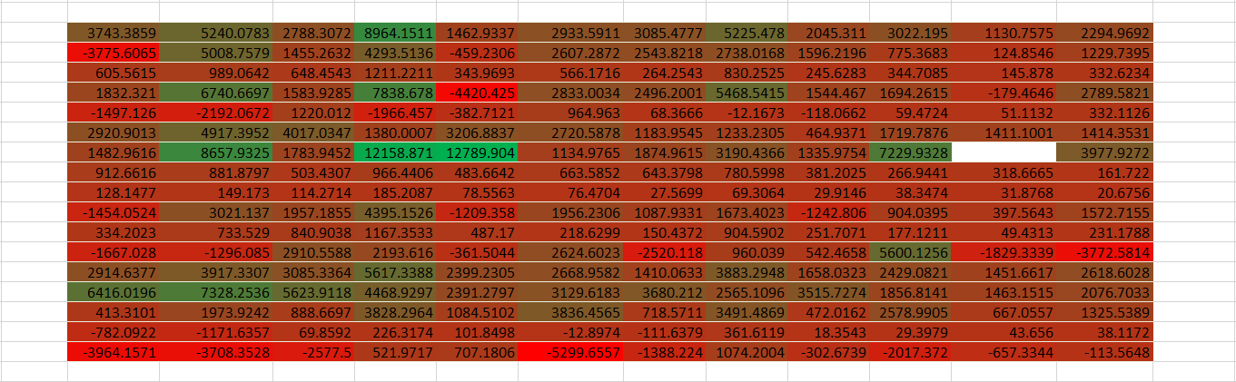

Task 2: To build a simple map, using Superstore dataset with location data (for example, location names or latitude and longitude coordinates (Region & State)).

**Results:-**

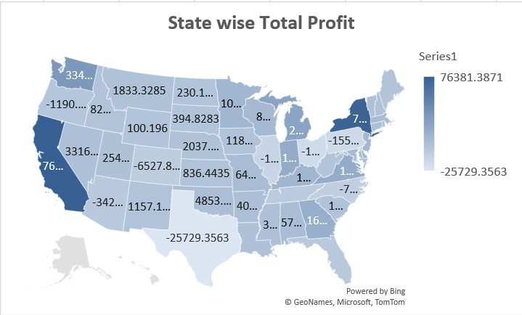

Task 3: To create a density heat map using the sample dataset pertaining to sales in an electronics store.

**Results:**

**In – Lab Tasks:**

Perform the following tasks using Tableau:

Task 1: To create a highlight table to explore how profit varies across regions, product sub-categories, and customer segments in the Superstore dataset

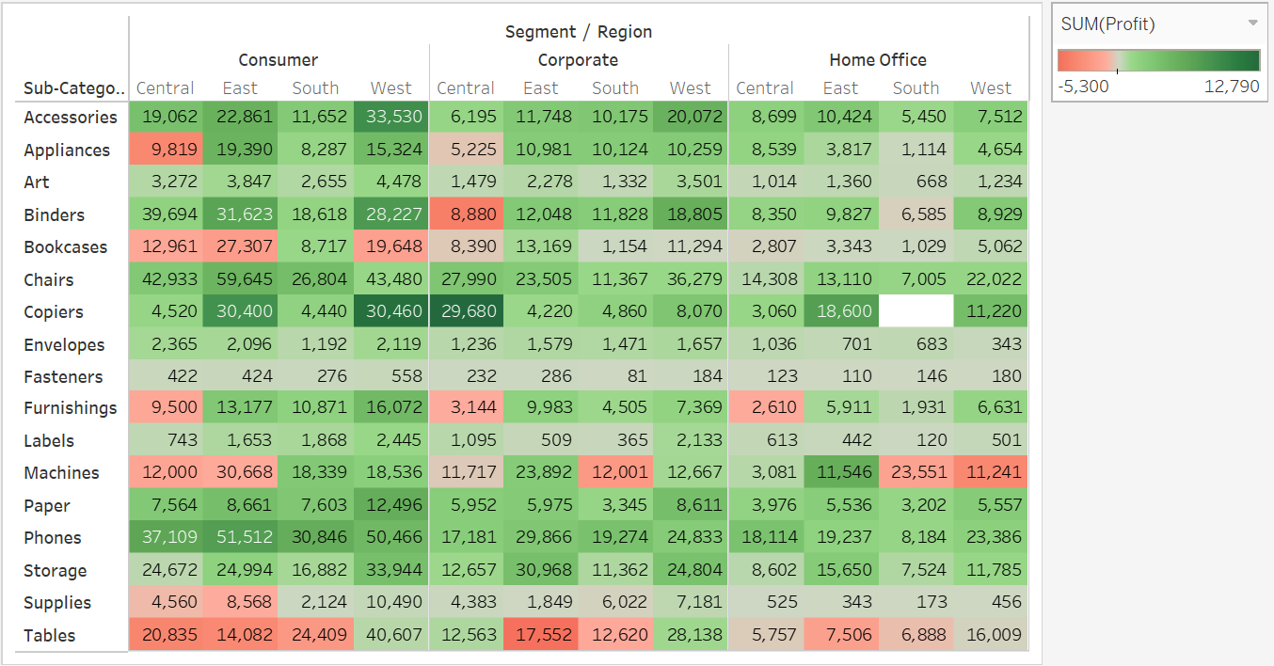**Results:-**

Task 2: To build a simple map, using Superstore dataset with location data (for example, location names or latitude and longitude coordinates (Region & State)).

**Results:-**

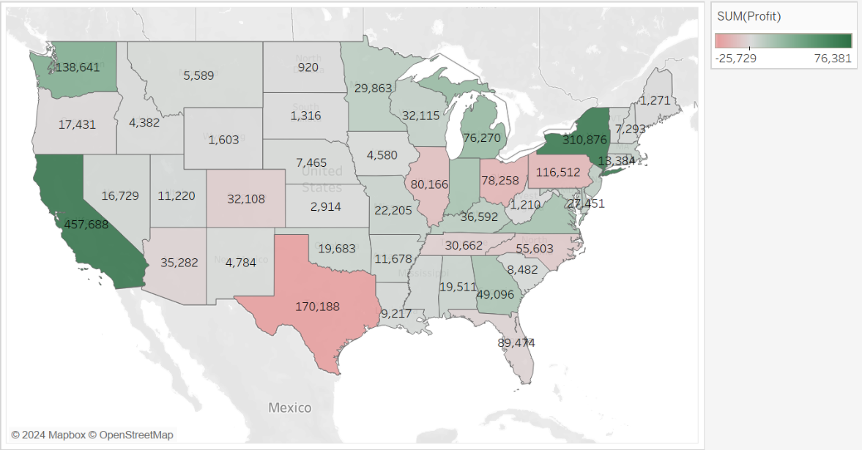

Task 3: To create a density heat map using the sample dataset pertaining to sales in an electronics store.

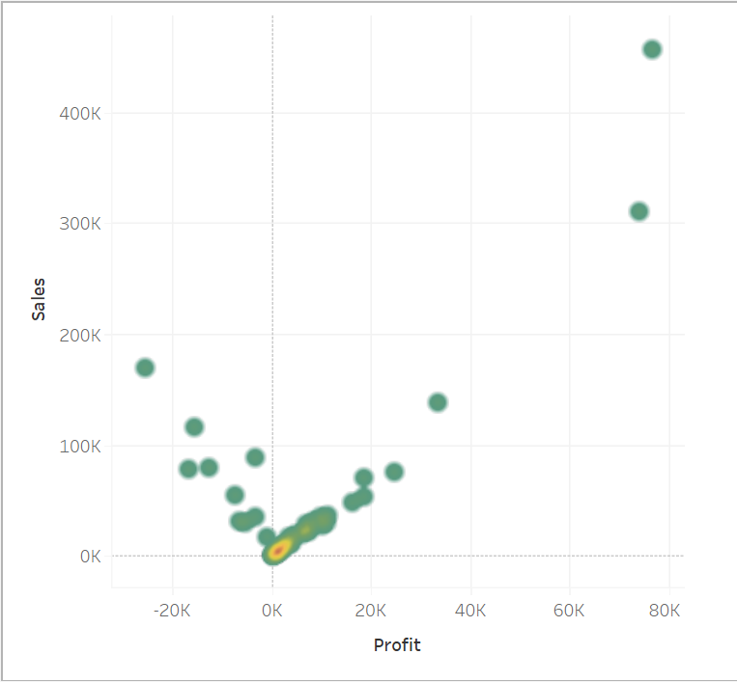**Results:-**

Reference Link: <https://help.tableau.com/current/pro/desktop/en-us/buildexamples_highlight.htm>

<https://data-flair.training/blogs/tableau-heat-map/>

**Observation and Result Analysis:**

Write the final observation and process corresponding to each task

**________________________________________________________________________________________________________________________________________________________________________________________**

**____________________________________________________________________________________________**

**________________________________________________________________________________________________________________________________________________________________________________________**

**____________________________________________________________________________________________**

**________________________________________________________________________________________________________________________________________________________________________________________**

**____________________________________________________________________________________________**

**Post Lab Exercise:**

**Python Implementation**

**Reference Link:** [**https://www.kaggle.com/code/suyashpratapsingh/eda-on-sample-superstore-dataset**](https://www.kaggle.com/code/suyashpratapsingh/eda-on-sample-superstore-dataset)

Perform the following tasks using Python:

**Pre- Requisities:-**

import pandas as pd

import seaborn as sns

import plotly.graph_objects as go

from plotly.offline import plot

from matplotlib.colors import LinearSegmentedColormap

import matplotlib.pyplot as plt

Dataset = pd.read_excel("./Sample - Superstore.xlsx", "Orders")

Task 1: To create a highlight table to explore how profit varies across regions, product sub-categories, and customer segments in the Superstore dataset

**Code:-**

Pivot_Table = pd.pivot_table(Dataset, values='Sales', columns=['Segment', 'Region'], index='Sub-Category', aggfunc='sum')

colors = [(1, 0, 0), (0, 1, 0)]

cmap_name = 'custom_colormap'

cm = LinearSegmentedColormap.from_list(cmap_name, colors, N=256)

plt.figure(figsize=(16, 8))

sns.heatmap(data=Pivot_Table, annot=True, cmap=cm, fmt='0.1f')

plt.title("Profit Analysis")

plt.xlabel("Region")

plt.ylabel("Sub-Category")

plt.show()

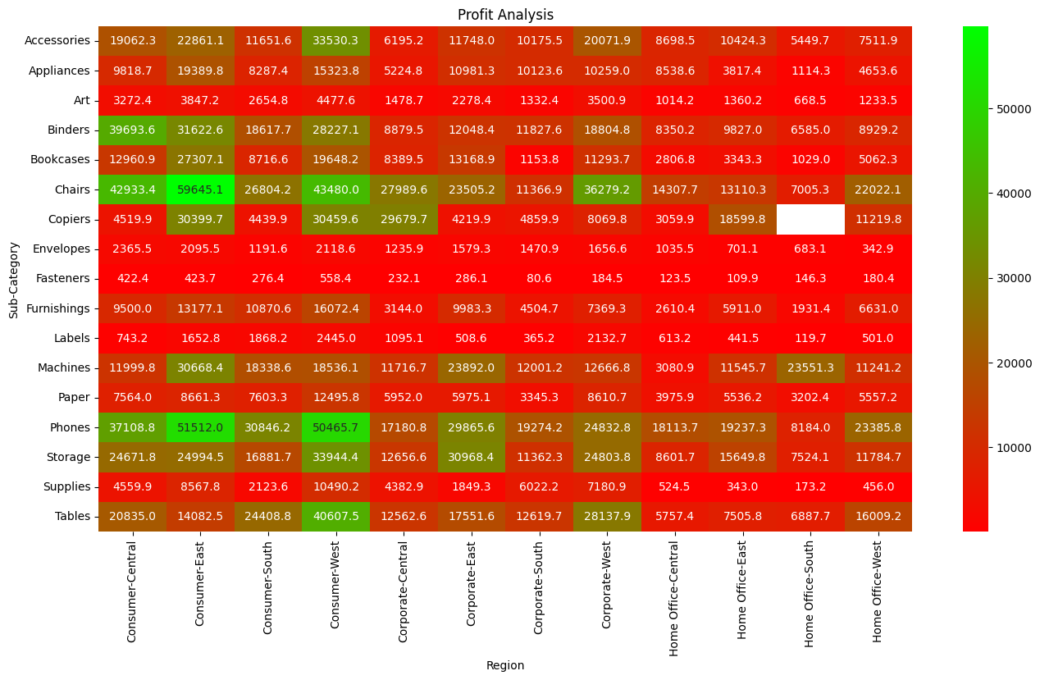**Results:-**

Task 2: To build a simple map, using Superstore dataset with location data (for example, location names or latitude and longitude coordinates (Region & State)).

**Code:-**

state_wise_profit = Dataset.groupby("State")["Profit"].sum().reset_index()

new_Dataset = pd.read_excel("./Sample - Superstore.xlsx", "Sheet6")

Map_Dataset = pd.DataFrame(

{ "State": state_wise_profit["State"],"Profit": state_wise_profit["Profit"],"State_Code": new_Dataset["State_Code"],})

Data = dict(type="choropleth",locations=Map_Dataset["State_Code"],locationmode="USA-states",colorscale="RdYlGn",text=Map_Dataset["State"],z=Map_Dataset["Profit"],colorbar={"title": "Profit"},)

layout = dict(geo={"scope": "usa"})

chmap = go.Figure(data=[Data], layout=layout)

plotly_html = plot(chmap, filename="choropleth_map.html", auto_open=True)

**Results:-**

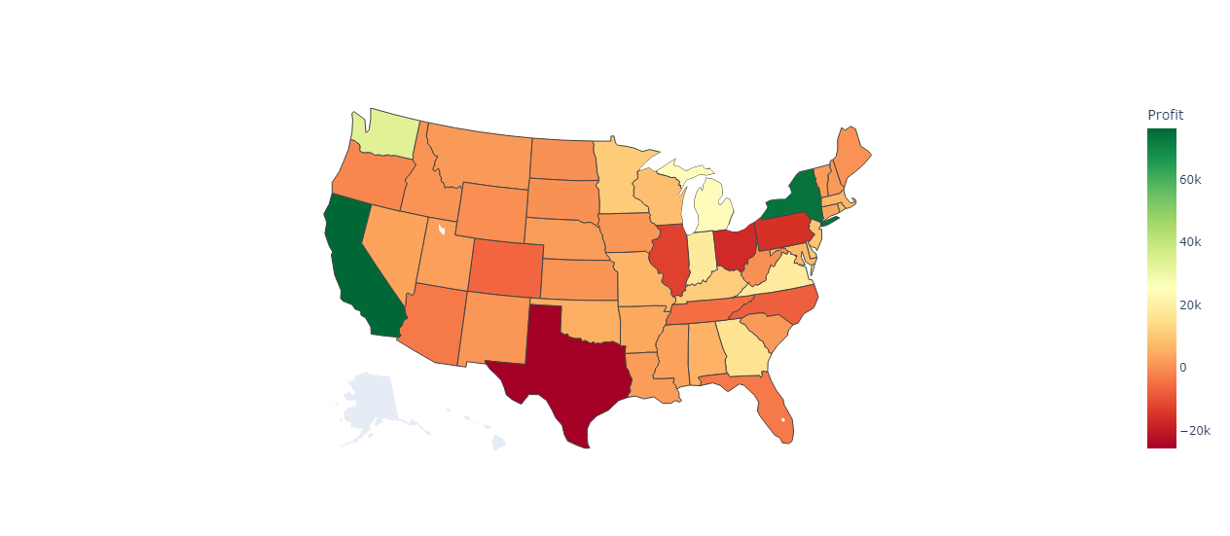

Task 3: To create a density heat map using the sample dataset pertaining to sales in an electronics store.

**Code:-**

New_Dataset = Dataset.groupby("State")[["Profit", "Sales"]].sum()

New_Dataset = pd.DataFrame(New_Dataset)

sns.kdeplot(data=New_Dataset, x="Profit", y="Sales", cmap="RdYlGn_r", fill=True)

plt.xlabel("Profit")

plt.ylabel("Sales")

plt.title("Density Heatmap of Sales and Profit")

plt.show()

**Results:-**

